The Bavaria Easy 9.7

EUR 425,000

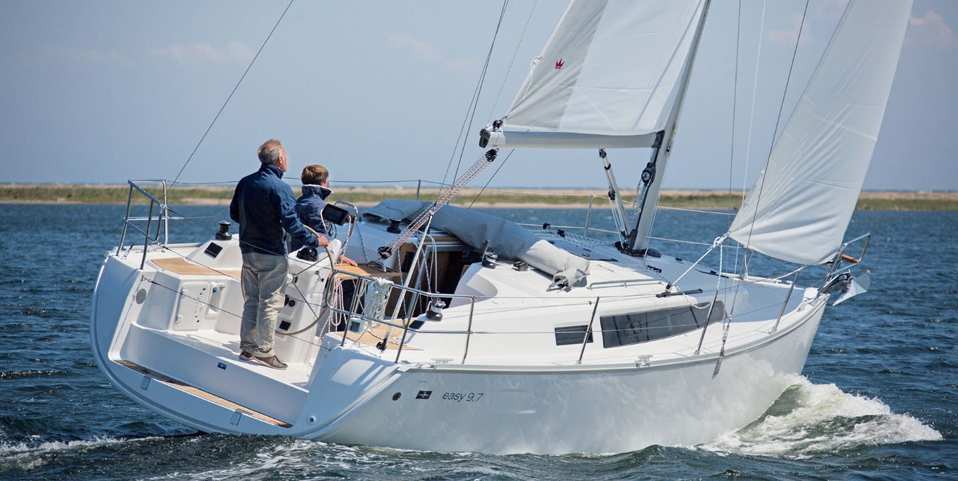

## Asking price: **EUR 425,000**

## Built: **2019, Venice, Italy**

## Length: **59.2m (290.6ft)**

## Cabins: **2**

## Berths: **2**

# Description:

# Focused on the essentials.

### A BAVARIA EASY 9.7 has an agile and athletic sailing performance – the designers of Farr Yacht Design and the development team of BAVARIA spent a great deal of time to ensure this. The 106 percent large head sail is sheeted closely on the deck structure. Including the mainsail, there are 51 square metres of sail area, which gives the BAVARIA EASY 9.7 an enormous speed potential even in light winds.